PRINTED BOARD MANUFACTURING SPECIFICATION

REV.  HISTORY | DATE |  | DESCRIPTION |  |  |  |  |  |  |  |  |  |  | RELEASE  AUTHORIZED BY
D | 7/31/12 |  | Delete paragraph 5.4 and renumber 5.5, coupons no longer required; Attachment I, delete (b), coupons for SDRL02.
E | 3/13/13 |  | Paragraph 4.2, 2nd bullet, add “if required by PO”. Update packaging requirement for silver immersion finishes.
F | 3/28/13 |  | Add paragraph 5.5; Add J-STD-003 to Applicable Documents.
G | 7/22/13 |  | Paragraph 4.1, change bullet for reference to IPC-SM-840 Class 3 to Class H or FH.
H | 11/26/13 |  | Paragraph 4.1: Add bullets 6 and 9 (non-conductive via fill and foil wrapping) and modify bullet 8. Paragraph 4.2a-g: Add ideal panel size. Paragraph 4.4: rewrite. Paragraph 4.6 renumber as 5.0; Para. 4.6 renumber to 6.0. Paragraph 6.1 rewrite. Paragraph 5.0 renumber to 7.0. Add 7.2.2 and 7.6.
J | 3/26/18 |  | Updated document to latest format. Corrected Titles in Applicable Documents. Paragraph 1.0: Deleted details to navigate website. Paragraph 1.1: Add color and semi-gloss as preferred. Paragraph 1.1 Added silkscreen color and spec. Paragraph 1.1 Added Panelization defect rate. Paragraph 1.4: Clearly state SELLER cannot proceed with any change unless in writing by the Buyer. Updated Paragraph 4.1: Buyer Standard Quality Requirements language and corrected titles of QR Clauses. Updated Paragraph 4.2.1 with testing spec and coverage. Add Paragraph 5.0. |  |  |  |  |  |  |  |  |  |  | JK
SHEET | 17 | 18 | 19 | 20 | 21 | 22 | 23 | 24 | 25 | 26 | 27 | 28 | 29 | 30 | 31 | 32
REVISION
SHEET | 1 | 2 | 3 | 4 | 5 | 6 | 7 | 8 | 9 | 10 | 11 | 12 | 13 | 14 | 15 | 16
REVISION | J | J | J | J | J | J | J | J | J

SCOPE
All applicable Printed Wiring Boards purchased for deliverable products shall conform to this QAIS.

purpose
- To provide general procurement requirements between Sechan Electronics, Inc. (BUYER) and SELLER for Types 2, 3 or 4 printed board technologies.
- To establish a Class 3 (High Reliability Electronic Products) product performance standard that is consistent with the IPC workmanship standards (IPC-A-600, IPC-6011, IPC-6012 and IPC-6013).

responsibility
The QA department is responsible for maintaining this procedure. Suggested corrections and clarifications shall be identified to the QA Department Office.

APPLICABLE DOCUMENTS
The following documents of the revision at time of this release form a part of this supplement to the extent specified herein. Revision applicable at date of BUYER order applies. Other applicable detail product drawings, specifications and requirements will be listed on the face of the BUYER order.

IPC-2221 | Generic Standard on Printed Board Design
IPC-2222 | Sectional Design Standard for Rigid Organic Printed Boards
IPC-4101 | Specification for Base Materials for Rigid and Multilayer Printed Boards
IPC-4103 | Specification for Base Materials for High Speed/High Frequency Applications
IPC-4202 | Flexible Base Dielectrics for Use in Flexible Printed Circuitry
IPC-4553 | Specification for Immersion Silver Plating for Printed Boards
IPC-6011 | Generic Performance Specification for Printed Boards
IPC-6012 | Qualification and Performance Specification for Rigid Printed Boards
IPC-6013 | Qualification and Performance Specification for Flexible Printed Boards
IPC-A-600 | Acceptability of Printed Boards
IPC-SM-840 | Qualification and Performance Specification of Permanent Solder Mask
IPC-TM-650 | Test Methods Manual
IPC-1601 | Printed Board Handling and Storage Guidelines
J-STD-003 | Solderability Tests for Printed Boards

TERMS AND Definitions

CTE | Coefficient Temperature Expansion
IPC Class 3 | High Performance Electronic Products. Includes products where continued high performance or performance-on-demand is critical, equipment downtime cannot be tolerated, end-use environment may be harsh, and the equipment must function when required, such as life support or other critical systems.
Panel Tool Holes | Locating holes on PWB panel
PTH | Plated Through Hole
PWB Panel | Multiple printed boards fabricated on a PWB panel for assembly ease. Layout configuration on the panel is optional but must be documented to BUYER.
PWB Scoring | Scoring of PWB material for ease of individual PWB removal. Approved scoring methods include either DSS (Double-Side Score) or SSS (Single-Side Score).
PWB, Type 2 | Double-sided printed board
PWB, Type 3 | Multilayer printed board without blind and / or buried vias
PWB, Type 4 | Multilayer printed board with blind and / or buried vias
T_{g} | Glass Transition Temperature

ORDER OF PRECEDENCE
In the event of differences and/or conflict among different requirements, the following order of precedence shall apply:

- The BUYER procurement order
- The master drawing or assembly drawing
- This order supplement
- Other applicable documents

Conflicts and planned resolution shall, however, be identified to the BUYER in writing (e-mail is preferred). To assure consistency in material provided, the BUYER may initiate a revision in the printed board master drawing and incorporate this change in the order structure.

1.0 GENERAL REQUIREMENTS
It is the intent that processes be consistent with normal SELLER operations and practices to the extent possible. However, material selection and process control requirements of this supplement shall be implemented unless a variance is authorized by the BUYER.

1.1 MATERIALS
The timely identification of material selection variances is valued and encouraged. Disposition of these variances shall be documented with mutual concurrence between BUYER and SELLER and shall become part of the printed board configuration baseline.

- It is recognized that drawing requirements (customer and otherwise) may not always specify some materials or that materials specified may be incompatible. Because of this, it is required that the
SELLER review materials selected for this printed board fabrication and that these materials be compatible and consistent with IPC-2222 par. 4 with regard to temperature characteristics (CTE and T_{g}). Laminates selected shall have glass transition temperatures (T_{g}) typically 170C or higher.
- The Pre-impregnated Bonding Layer (Prepreg) shall conform to the types and requirements listed in IPC-4101 and shall be compatible with copper clad laminate, as applicable.
- Adhesives selected shall be compatible and consistent with IPC-2221 par. 4.2.2 and 4.2.3 and IPC-4101, as applicable
- Laminate materials shall be selected from material listed in IPC-4101, IPC-4103 or IPC-4202, as applicable.
- Conductive materials used in the printed board construction shall be in accordance with IPC-2221 par. 4.4 and Table 4-3 for IPC Class 3 product. Conductive materials and printed board exterior finish shall be as required by master drawings and shall be compatible with other materials used in printed board construction.
- Non-conductive via fill on blind and buried vias shall be used unless specified on the print.
- Solder mask coatings and markings shall be compatible with each other and other materials in the printed board and shall be in accordance with IPC-SM-840, Class 3. Masking coverage must be uniform and complete, semi-gloss Green is preferred.
- Silkscreen marking shall be in white ink per A-A-56032, Type II using uppercase characters of matching height.
- It is preferred that when the printed board has via holes, these through ‘via’ holes are tented with solder mask material unless otherwise directed in the board fabrication files.
- Foil wrapping in accordance with IPC-4562 is permissible if the stack-up is not defined in the drawing package.

1.2 mechanical / physical properties
- The bow and twist of finished bare printed board product shall not exceed IPC-2221 par. 5.2.4 requirements for Class 3 product. Values are measured consistent with requirements of IPC-TM-650 Method 2.4.22.
- If required by PO, Printed board panelization shall be as required by IPC-2222 and this BUYER order supplement.
- PTH printed board (or combined SMT / PTH technology) panel shall not be larger than 16” x 16” and shall include a minimum border of 0.4” on at least two parallel sides. The ideal size for Sechan is 15” x 11” and all designs shall be evaluated to fit on this size prior to increasing to the maximum.
- SMT printed board panel shall not be larger than 16” x 18” and shall include a minimum border of 0.4” on the 16” panel dimension.
- Refer to Figure 1 for a typical printed board panelization layout.
- Routed width between printed board and panel shall be 0.100” +/- .005”.
- Panel tooling holes are required at three locations. Panel tooling holes shall be 0.125” +.003”/ -.000”
- Fiducials are to be placed on the tooling tabs near the three mounting holes.
- Panel break-away tabs shall use either (a) single side score or (b) double side score. All other tab break-away conventions require BUYER approval before use. Refer to Figures 2.
- BUYER requires electronic media with revisions (as needed) of the selected panelization layout. This layout configuration media shall be provided as early as practical and will become the basis for panelized PWB acceptance. Submit media per requirements of SDRL01.
- When panelized printed boards are authorized, the Supplier may deliver panels with defective printed boards provided (1) total defective printed boards on each individual panel does NOT exceed one and (2) the shipping lot does NOT contain more than 3% total 'X-Out' printed boards. Defective printed boards MUST be clearly identified and grouped in the shipping lot.

1.3 Printed board workmanship
Printed board workmanship (both external and internal observable characteristics) shall be consistent with IPC Class 3 product performance standards (IPC-A-600, IPC-6011, IPC-6012 and IPC-6013). This criterion will be used as part of the BUYER acceptance process.

1.4 TECHNICAL DATA PACKAGE
Sechan shall be provided a written copy, in the SELLER’s format, of any changes to the fabrication data needed to support manufacturing. Unless authorized in writing by the BUYER, the SELLER shall NOT proceed with any changes until formal approval is provided by the BUYER. If BUYER determines that the changes result in a significant contradiction, the BUYER shall provide the SELLER with additional change paper accepting or rejecting the change(s).

See paragraph 5.0 herein for additional guidance.

Figure 1, Typical Panelized Layout

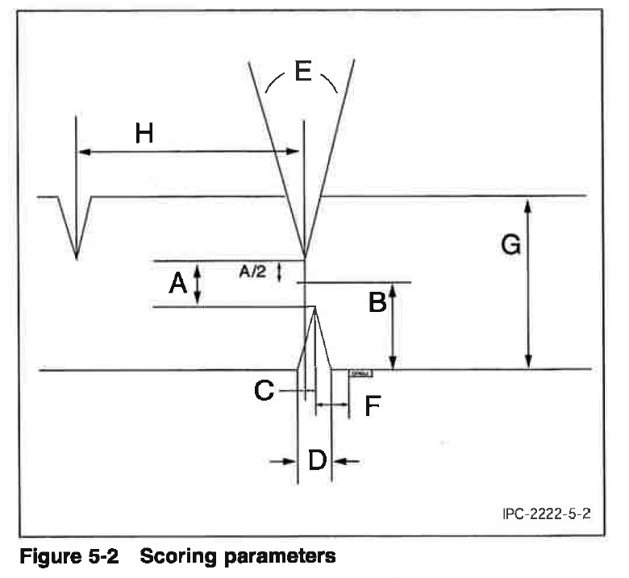

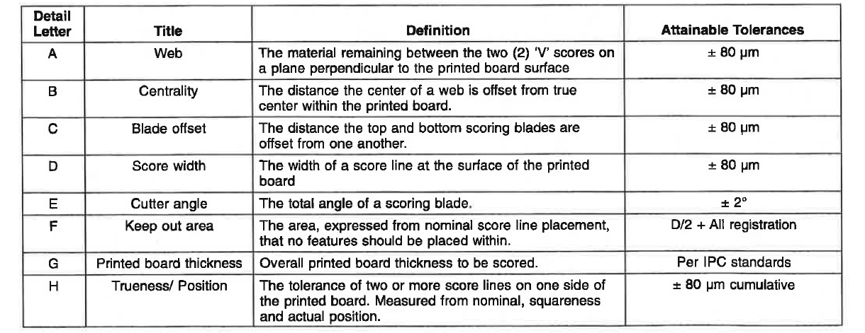
Figure 2, Breakaway Tab Detail

2.0 PRODUCT MARKING AND SERIALIZATION
Each printed board shall be identified and traceable to the SELLER fabrication lot in accordance with IPC-2221 and shall include:
- Printed board part number and revision
- Traceability identification
- Production lot date code
- Manufacturer’s identification

3.0 PACKING/PACKAGING/LABELING AND SHIPMENT
SELLER selected packing and packaging shall be suitable for the intended purpose, providing proper protection for the Printed board using IPC-1601, paragraph 4 as guidance.

3.1 Silver Immersion Finish
SELLER shall package per IPC-4553, Section 3.8. Boards shall be individually packaged immediately after processing. Air shall be vacated from the individually packaged board. Interleave may be used only if it is certain to not react with the silver finish. Desiccant and other silver reactive materials shall not be used.

3.2 All Other Finishes
Additionally, each PWB shall be packaged with interleaving material such that the PWB is not in direct contact with an adjacent PWB. The packaging material selected shall not leave residual material on the PWB surface.

Quality assurance

4.1 BUYER STANDARD QUALITY REQUIREMENTS
The following BUYER Standard Quality Requirements apply. QR clause language may be found on the BUYER web site at www.sechan.com. On the Home page click on the ‘Suppliers’ tab and then select ‘Quality Requirements’ to download the QR Clauses.

QR-2 Supplier Quality System
QR-3 General Purchase Order C of C
QR-3.2 Quality Record Retention
QR-3.3 Raw Material Certification
QR-4 Supplier’s Corrective Action System
QR-5 Supplier Configuration Control
QR-6 Sechan Visitation Authority
QR-7 Nonconforming Material Disposition
QR-15 Acceptance Test Reports
QR-25 First Article Inspection Report
QR-32 Printed Board Fabrication

4.2 PRinted Board electrical TEST data

4.2.1 Each printed board delivered shall be electrically tested for proper continuity per IPC-A-600 section 5.2 using the BUYER provided documentation (Gerber or CAD extracted netlist or equivalent). This testing includes both continuity and internal short testing. Certification to this requirement is required for each deliverable; a physical product stamp (or mark) on the printed board is preferred. Submit test certification per SDRL02.

4.2.2 Supplier shall provide a copy of the netlist, or equivalent, used to perform the test that includes the pass/fail values, for reference the first time a board part number is delivered to Sechan.

4.3 material CONFORMANCE CERTIFICATION
Each printed board lot delivered shall include material certifications for materials used in PWB fabrication process (refer to paragraph 4.1 above) and QR-3.3. As a minimum, these certifications shall include:
- SELLER and SELLER’s batch lot identification
- Laminate manufacturer’s certification
- Prepreg manufacturer’s certification
- Adhesive manufacturer’s certification
- Other material certifications if specified in the master drawings
- Submit material certifications per SDRL02.

4.4 PROBLEM INVESTIGATION REPORT
Printed board failures returned to SELLER shall be analyzed for root-cause and corrective action. A Problem Investigation Report (PIR) shall be issued to the BUYER in accordance with SDRL03.

4.5 j-std-003 category 3
When Category 3 testing is required by Contract (PO, Drawing, etc.). The SELLER shall provide a report certifying compliance to the requirement for each delivery.

4.6 COUPONS
In addition to the IPC-2221 A coupon, Supplier shall generate a B coupon (with input from Sechan as required) in order to characterize and evaluate each blind, buried or filled through hole via. The B coupon is to be designed for registration evaluation. Its construction should insure that both minimum annular ring and minimum spacing between plated holes and circuitry are met. The B coupon shall have a land size that makes this possible, even if that size pad with that particular drilled hole diameter does not exist on the part.

4.7 SUPPLIER DATA REQUIREMENTS LIST (SDRLs)
Attachment I presents the required requirements by this QAIS.

5.0 SELLER GUIDELINES FOR PROCESS FLEXIBILITY
There are certain aspects of PWB fabrication that may be determined by the SELLER without BUYER approval. The following provides guidelines for the specific items, categories that the SELLER may proceed without BUYER concurrence or approval. All other items must be in accordance with 1.4 herein.
- Etch compensation - The Supplier is permitted to increase the sizes of copper features to allow for the etch process to etch down to the target feature size and spacing.
- Silkscreen Clipping - The Supplier is permitted to clip any silkscreen marking to avoid ink getting onto solderable pads or into holes.

ATTACHMENT I
SUPPLIER DATA REQUIREMENTS LIST
The following documentation is required. Reports may be submitted in SELLER format; unless otherwise specified, only one (1) copy of each submission is required. All technical data submitted shall be identified with the BUYER order and with the name and address of the SELLER.

ITEM | FREQUENCY | DESCRIPTION
SDRL01 | Once w/revisions | Electronic media of the selected panelization layout shall be provided. Provide this layout media as early as practical.
SDRL02 | Each deliverable lot | LOT ACCEPTANCE DATA including (a) material conformance certifications.
SDRL03 | As Required | PROBLEM INVESTIGATION REPORT – Submitted as required

